PROGRAM
import cv2
import matplotlib.pyplot as plt
def analyze_histogram(image):
colors = ('b', 'g', 'r')
names = ('Blue', 'Green', 'Red')
for i in range(3):
histogram = cv2.calcHist(
[image], [i], None, [256], [0, 256]
)
plt.plot(histogram, color=colors[i], label=names[i])

plt.title("Color Histogram")
plt.xlabel("Color Intensity (0-255)")
plt.ylabel("Number of Pixels")
plt.legend()
plt.xlim([0, 256])
plt.show()
image = cv2.imread("color_fruits.png")
if image is None:
print("Image not found. Check the file name.")
else:
cv2.imshow("Original Image", image)
analyze_histogram(image)
cv2.destroyAllWindows()

INPUT
The input image used in this experiment is color_fruits.png, which contains fruits with different colors.
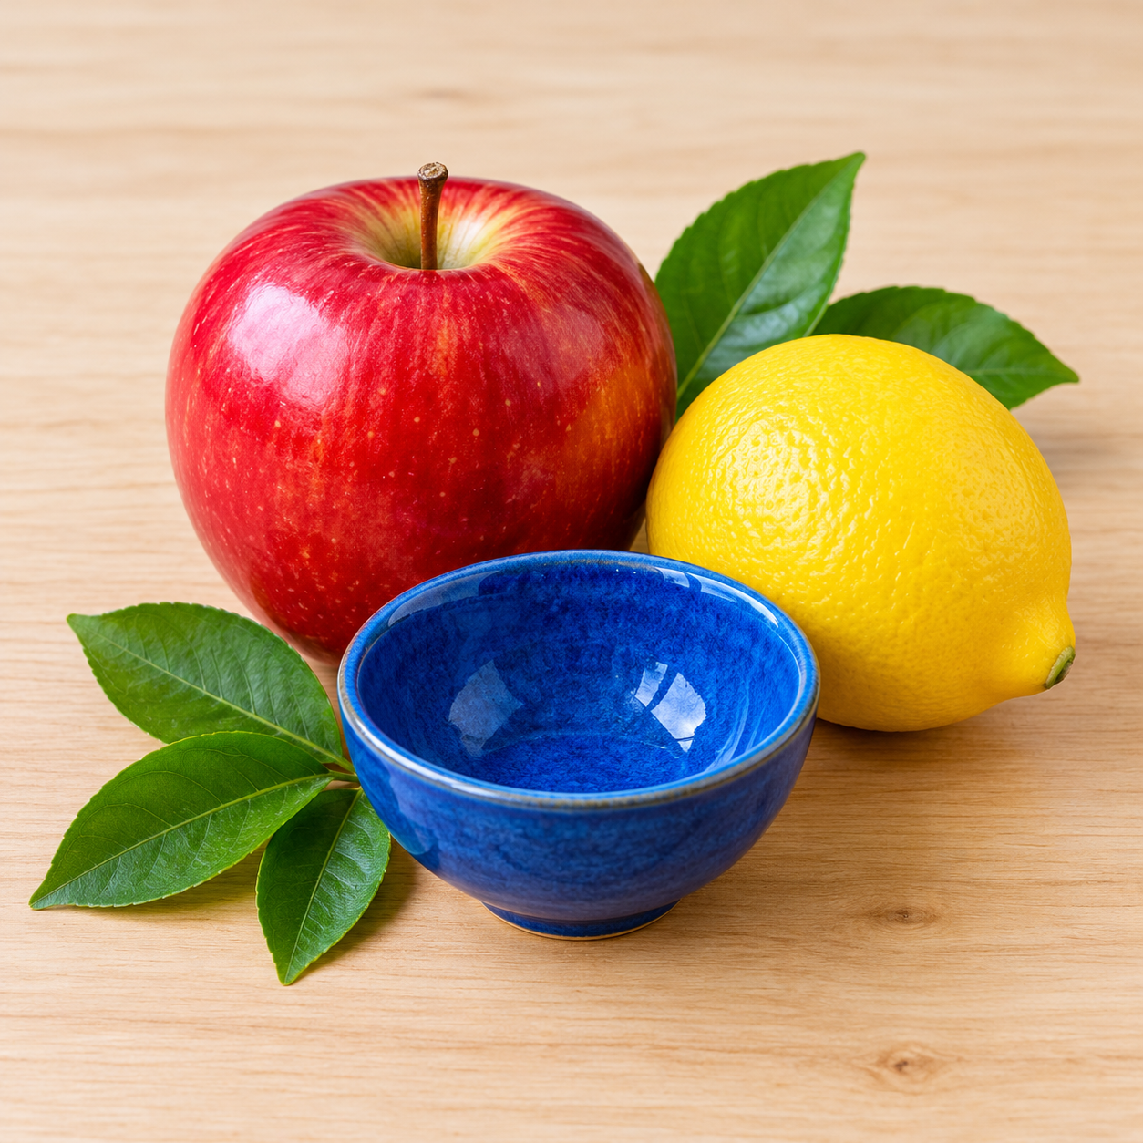

OUTPUT
The original fruit image and a color histogram showing the Blue, Green, and Red color intensity levels are displayed.
